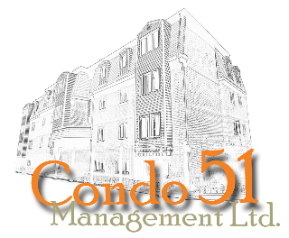
HCCC #264 – 32-40 Veronica Dr.
UNIT INFORMATION FORM

Unit #: ____ - ____________ Date: _____________________________

Owner Name(s): _________________________________________________________________________
Mailing Address: _________________________________________________________________________
Contact Numbers: H. ______________________ W. ______________________ C. ____________________
Email: _________________________________________________________________________
Occupied by: Owner ______ Tenant ______
If Rented, Managed by: Owner _______ Management Company ________________________________________
Management Company contact info: email: _______________________________ Phone: ___________________

If Occupied by Tenant, please provide contact information below:
Tenant Name(s) _________________________________________________________________________
Contact Numbers: H. ______________________ W. ______________________ C. ____________________
Email(s) _________________________________________________________________________
Names and email of All Residents occupying the unit:
_________________________________________ ________________________________________
_________________________________________ ________________________________________

Unit Alarmed: YES ______ NO ______ Name of Alarm Company: ___________________________________
Pets: YES ______ NO ______ How Many: ___________________________________________
If YES, please provide details (breed, weight, name(s)): ____________________________________________________________________________________________

Vehicle Information: Make: ___________________ Model: ______________________
Color: ___________________ Plate #: ______________________
Second Vehicle: Make: __________________ Model: ______________________
Color: ___________________ Plate #: ______________________

Emergency Contact Information:
Name(s): ____________________________________ Relationship: _______________________
Contact Numbers: H. ____________________ W. ____________________ C. __________________

Is Assistance Required During an Emergency: Yes ______ No ______
If YES, please provide type of assistance required ____________________________________________________
If you rent your unit, you are required to file the below undertaking.

“I , undertake that I, the members of my household and my guests from time to time will, in using the Unit rented by me and the Common Elements, comply with the Residential Tenancies Act and the Condominium Act, the Declaration, and By-laws, including Common Elements Rules, and all other rules and directions of the Condominium Corporation during the term of my tenancy.”

Signed:

Name:

Unit Number:

Date:

